


Cairo University
Faculty of Computing and Artificial Intelligence
Computer Science Department

InspaceAI: Platform Agnostic
UI Testing Through Computer-Use Agents

Supervised By
Dr. Mohamed Elramly
TA. Esraa Salem

Implemented By
20220408 | Yousef Mohamed Farouk
20220495 | Eslam Sayed Younus
20220390 | Youssef Hossam Ahmed
20220194 | Abdalrhman Magdy Eid
20220386 | Yosef El-Mekkawy Mohamed

Graduation Project
Academic Year 2025 – 2026
Mid-year Short Documentation

- Abstract
In the fast-paced world of modern software development, maintaining high quality software is a constant challenge. Traditional automated testing approaches often struggle to maintain reliability and scalability. This project presents a Computer Use Agent (CUA) framework designed for platform-agnostic UI testing automation.
The system leverages a layered architecture combining perception, reasoning, and action: a vision-based parser interprets user interfaces into structured data, a cognitive orchestration layer determines logical actions, and an execution layer performs automated interactions. By abstracting test automation from platform-specific details, the framework reduces maintenance overhead, improves robustness against UI changes. This project provides a scalable, intelligent solution for modern QA challenges, benefiting software developers, QA engineers, and organizations seeking efficient, low-maintenance automated testing for complex applications.

- Background
  - Challenges
Modern software applications are increasingly dynamic, complex, and visually rich, often built using frameworks like React, Tailwind, and micro-frontends. Traditional automated testing approaches, such as Selenium and Playwright, rely heavily on static code-based selectors (e.g., XPath, CSS IDs), making them brittle and prone to breaking when the UI changes, even slightly. This creates significant challenges for quality assurance teams, who spend a large portion of their time maintaining and updating test scripts rather than focusing on testing itself.

Furthermore, existing automated tools frequently struggle to achieve comprehensive testing coverage, often becoming trapped in loops or disproportionately focusing on a limited subset of app pages. This creates significant challenges for quality assurance teams, who spend a large portion of their time maintaining and updating test scripts rather than focusing on testing itself. Additionally, while testing web and mobile applications are established research fields, automated testing of apps that require cross-platform interactions remains an underexplored area.

  - Motivation and Beneficiaries
The motivation behind this project is to improve the reliability, scalability, and adaptability of UI testing by designing a platform-agnostic system capable of interacting with user interfaces in a human-like manner. The system benefits software developers, QA engineers, and organizations that need robust, low-maintenance automated testing for applications across multiple platforms.

A critical motivator for InspaceAI is the increasing need for cross-device and cross-platform consistency. In daily life, user interaction often spans multiple devices; for example, a user might begin writing an email in a web browser and finish it on a mobile application. Developers are under pressure to ensure high-quality interactions across these different environments. However, traditional tools often treat the main app as a black box or fail to support interaction between different devices (e.g., Android to Web). InspaceAI addresses this gap by abstracting the testing process into a visual, platform-agnostic agent capable of navigating these heterogeneous environments.

  - Main Techniques and Technologies
To achieve platform-agnostic testing capability, InspaceAI integrates state-of-the-art advancements in Generative AI with CV Models and Agentic protocols. The system architecture is built upon three primary technological pillars:
    - Perception
Unlike traditional tools that parse the Document Object Model (DOM) or XML view hierarchies, our system captures real-time screenshots of the interface, parses it using Omniparser, a UI parsing opensource model developed by Microsoft, to identify locations for each UI Element on the screen.
To improve interaction accuracy, we employ visual prompting techniques that overlay numeric tags and bounding boxes on the screenshot before feeding it to the reasoning model.
    - Reasoning and Orchestration
We use Vision-Language Models (VLMs) to generate action plans for executing each test step. By combining these plans with our labeled images, the model can understand what each bounding box represents and determine the appropriate action to perform.
We use LangGraph to orchestrate the system’s nodes and manage cyclic workflows. We also implement a short-term memory module that tracks the agent’s action history. This prevents cyclic behaviors (such as clicking the same button repeatedly) and ensures the agent maintains context across multi-step workflows.
    - Action
The core logic outputs high-level actions (e.g., click(x, y), type("text")). A translation layer then converts these into specific OS commands desktop for example uses libraries like PyAutoGUI to control the mouse and keyboard on Windows/Linux/macOS, on the web we use headless browser interface treating the browser is another application window.
    - Evaluation
Assesses the success or failure of a test step and identifies potential reasons for failure in order to explore possible fixes. If the Evaluator determines that an action has failed (e.g., a popup blocking a click), it rejects the current state and signals the Reasoning Node to generate a new plan.
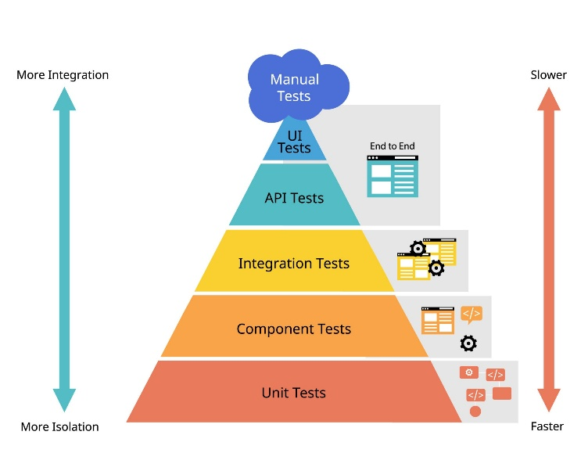
- Problem Definition
The primary bottleneck in modern UI testing lies in the inherent fragility of traditional frameworks such as Selenium or Playwright. Because these tools depend heavily on static, code-based selectors like XPath or CSS IDs, even minor modifications to a user interface can render test scripts obsolete.

This fragility creates a disproportionate maintenance overhead, forcing Quality Assurance teams to dedicate a significant portion of their resources to updating and repairing broken scripts rather than focusing on accelerating software delivery.
Furthermore, current automation solutions lack intelligent UI understanding. They are unable to interpret UI semantics or make human-like decisions, which severely limits their reliability and scalability. This deficiency becomes particularly evident during exploratory testing, where existing tools struggle with dynamic content and unexpected layouts. As a result, scenarios not explicitly anticipated in the hard-coded scripts often require manual intervention, undermining the goal of fully autonomous quality assurance.

- Related Work

The development of InspaceAI draws inspiration from recent advancements in AI agents, LLM-guided exploration, and cross-platform testing frameworks. Below, we discuss how these works relate to our proposed solution.

  - LLMDroid: Enhancing Automated Mobile App GUI Testing Coverage with LLM
Recent frameworks like LLMDROID (Wang et al., 2025) have demonstrated the power of Large Language Models (LLMs) in enhancing mobile GUI testing. LLMDROID addresses the limitations of traditional tools by using LLMs to make high-level decisions when coverage growth slows, effectively "breaking out" of testing loops.

  - UXAGENT An LLM-based Usability Testing Framework for Web Design (Lu et al., 2025)
Introduces a novel framework for simulating human behavior in web environments. It utilizes a "Persona Generator" to create diverse user profiles and an LLM-driven agent to interact with web designs, mimicking how real users might navigate a site. This approach shifts the focus from simple "pass/fail" assertions to understanding how a user interacts with an interface.
  - AppAgent: Multimodal Agents as Smartphone Users
A key inspiration for our platform-agnostic approach is AppAgent (Yang et al., 2023). Unlike traditional tools that query the underlying code of an application, AppAgent utilizes a multimodal Large Language Model (LLM) to interact with smartphone applications purely through visual perception. It mimics human interaction by analyzing screenshots and simulating touch gestures (tapping, swiping) without requiring any system-level access or XML file parsing.

- Competitors
Tool / Framework | Core Technology | Strengths | Weaknesses | Differentiation
Selenium / Playwright | - Script-Based (DOM)  - Rely on code selectors (CSS/XPath) to drive the browser. | - Precise, low-level control over browser interactions. | - Scripts break easily - when UI changes  - Requires constant code updates.  - Cannot handle dynamic/unforeseen logic. | - InspaceAI figures out how to execute a goal (e.g., "Login") without hard-coded steps.
Mabl | - Low-Code flows  - Record-and-playback with auto-healing selectors. | - Automatically fixes broken selectors to keep tests running.  - No coding required; accessible to non-technical QA. | - Primarily focused on web apps, lacking true desktop/mobile support.  - Proprietary platform; hard to export tests. | - InspaceAI is Platform Agnostic. Mabl is trapped in the browser/cloud.  - You don’t need to configure low-code workflows
Zero Step | - AI Plugin (for Playwright)  - Adds natural language commands to Playwright scripts. | - Easy to add to existing Playwright suites.  - Replaces brittle selectors with AI text prompts. | - Can only interact with what the browser's code exposes | - InspaceAI reads the pixels. This allows us to test things that have no DOM

- Project Specifications
  - System Architecture

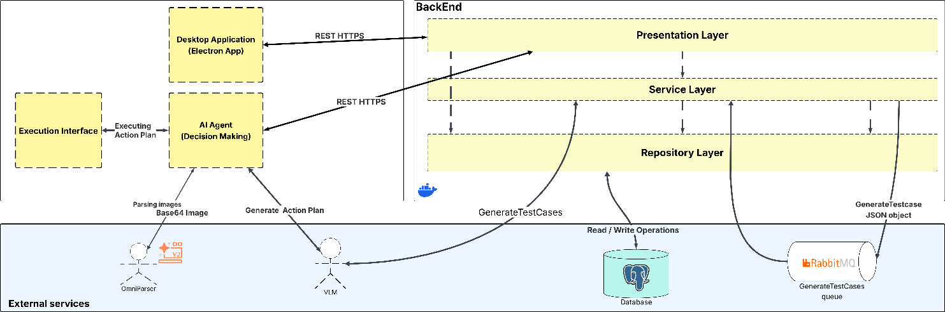

  - Stakeholders
    - Primary Users (QA Engineers): Responsible for creating test scenarios, reviewing automated reports, and maintaining quality standards.
    - Secondary Users (Software Developers): Use the system to debug UI failures and verify fixes before deployment.
    - Project Managers: View high-level dashboards and pass/fail metrics to make release decisions.
    - Software Testing Companies Such as Qestit.
    - Software Development Companies

  - Functional Requirements
FR-01. The system allows users to register and authenticate using secure token mechanism.
FR-02. The system shall allow users to create and manage projects for organizing automated tests.
FR-03. The system shall allow users to create and manage modules within each project to group related user stories.
FR-04. The system allows users to generate automated test cases using a Large Language Model (LLM).
FR-05. The system shall allow users to view, edit, and delete test steps before executing a test case.
FR-06. The system shall maintain history for test cases that got executed.
FR-07. The system shall allow users to execute test cases from within the application.
FR-08. The system should provide a dashboard to display real-time test execution status.
FR-09. The dashboard shall display test configuration details, execution progress, system logs, and a live preview of the execution environment.
FR-10. The system shall provide REST APIs for communication between the frontend and backend components.
FR-11. The system shall record and store a video of each test execution session.

  - Non-Functional Requirements
    - Performance & Responsiveness
- NFR-01 Response Time: The system shall aim to respond to user interface requests within a reasonable time (approximately 2–5 seconds) under normal load.

- NFR-02 Provisioning Speed: The system aims to provide a new test execution environment for approximately 60 seconds.

- NFR-03 Execution Limit: The system shall be optimized to execute a standard test step in a worst-case scenario of 60 seconds, depending on the complexity of the test step.
    - Scalability & Reliability
- NFR-04 Horizontal Scaling: The system shall be designed to support horizontal scaling, allowing for the addition of more worker nodes to handle increased workload.
- NFR-05 Availability: The system shall target availability of at least 98% during standard operational hours.
- NFR-06 Fault Recovery: The system shall provide basic fault recovery mechanisms for failed execution environments, such as automatically restarting a crashed container or retrying a failed connection.
    - Architecture & Maintainability
- NFR-07 Modular Architecture: The system shall follow a modular architecture to allow independent updates and deployment of system components (e.g., updating the Vision Agent without taking down the Dashboard).

- NFR-08 Separation of Concerns: The system shall have a clear separation between frontend, backend, and AI model components to improve code maintainability and team collaboration.

- NFR-09 Deployment: The system shall support container-based deployment (e.g., Docker, Kubernetes) to ensure consistency across development, testing, and production environments.
    - Usability & Observability
- NFR-10 Visualization: The system shall provide clear visualization of test execution progress in the dashboard, allowing users to track steps in real-time.
- NFR-11 Usability: The system shall not block the user’s activity to execute tests, but run in a non-blocking environment.

    - Security
- NFR-12 Credential Security: The system shall store user credentials securely using industry-standard hashing techniques

- NFR-13 Prompt Sensitive Information: If a test case requires entering sensitive information, never send this information through the network, instead save them locally to use them as variables.

  - Use-Case Diagrams
    - Testcase Generation Use Case
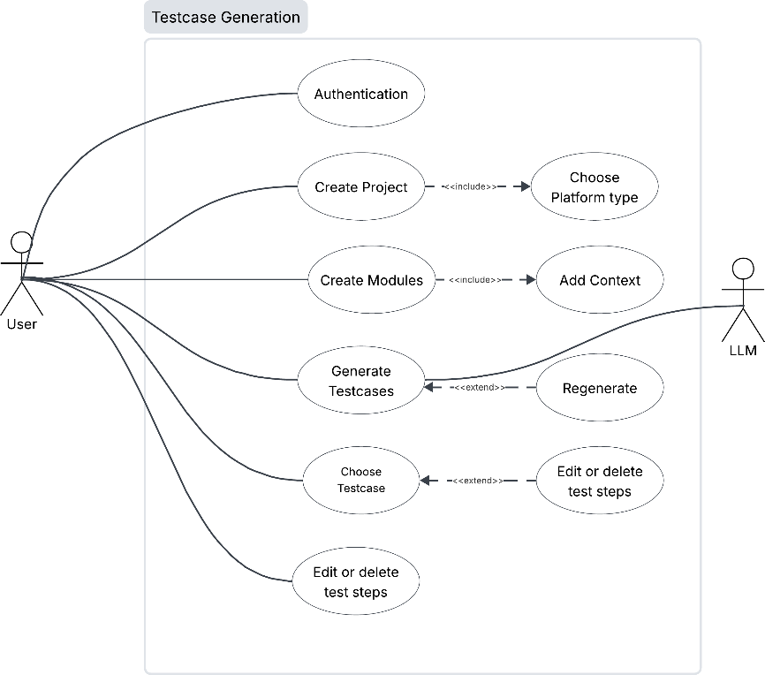
This system is designed to assist users in creating, managing, and generating automated test cases using a Large Language Model (LLM). The flow starts by authentication, creating a project and defining different modules inside this project (e.g. Authentication Modules) and using the given user stories, documents, screenshots or DOM trees as context, we generate test cases for the execution.

    - Test Execution Use Case
This system manages the execution of test cases. When a User runs a test, the system sets up the environment and enters an execution loop: it parses the screen and generates actionable steps using VLM. The system executes these actions, updates the status of each step, and includes a fallback mechanism to Retry on Failure.
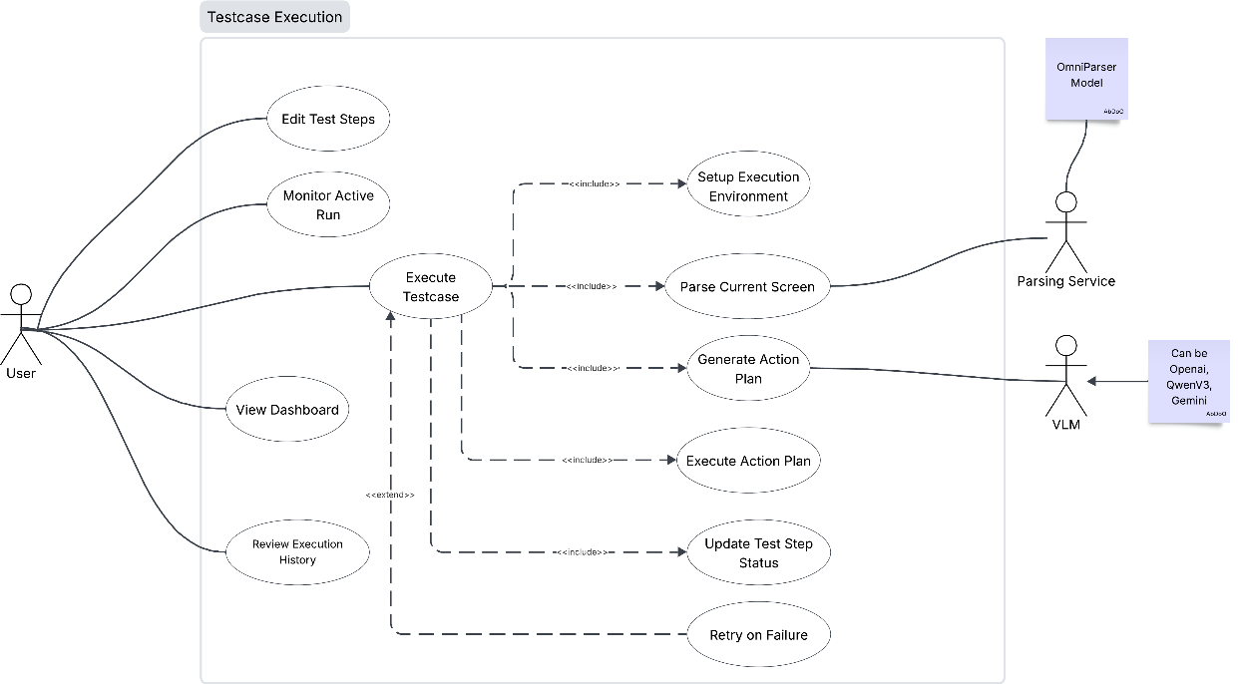
  - Database Class Diagram
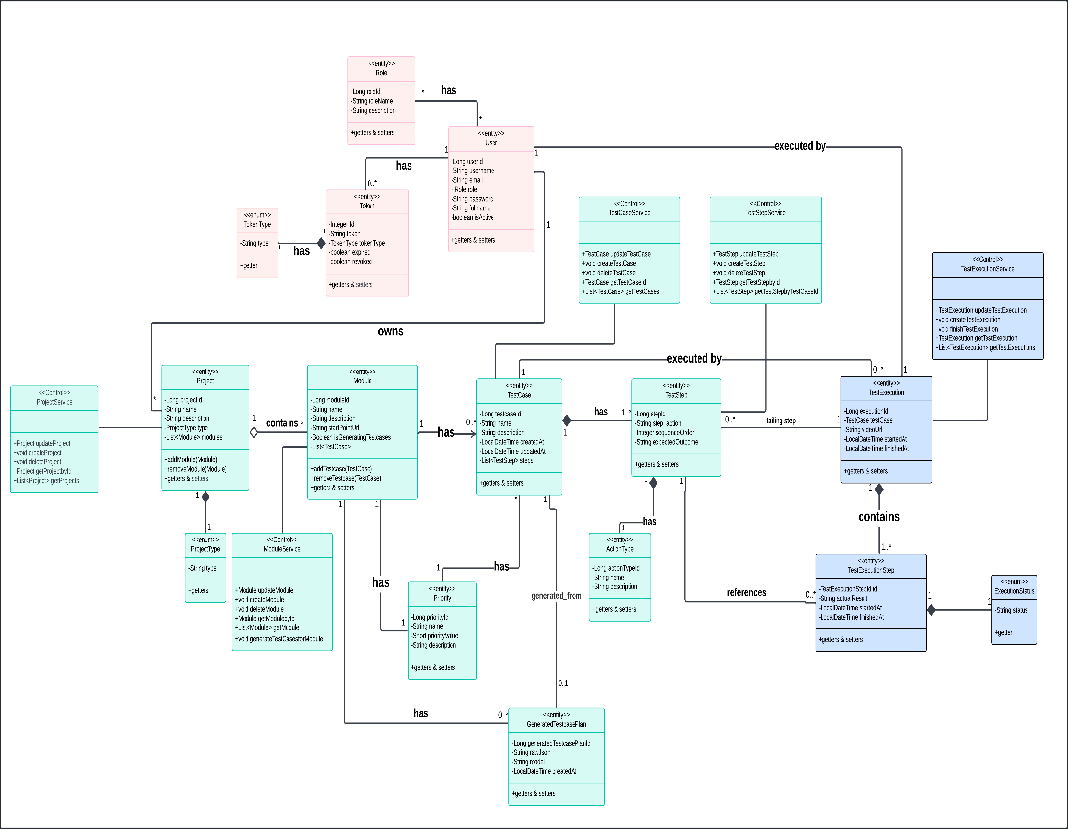
Figure 1 Class Diagram
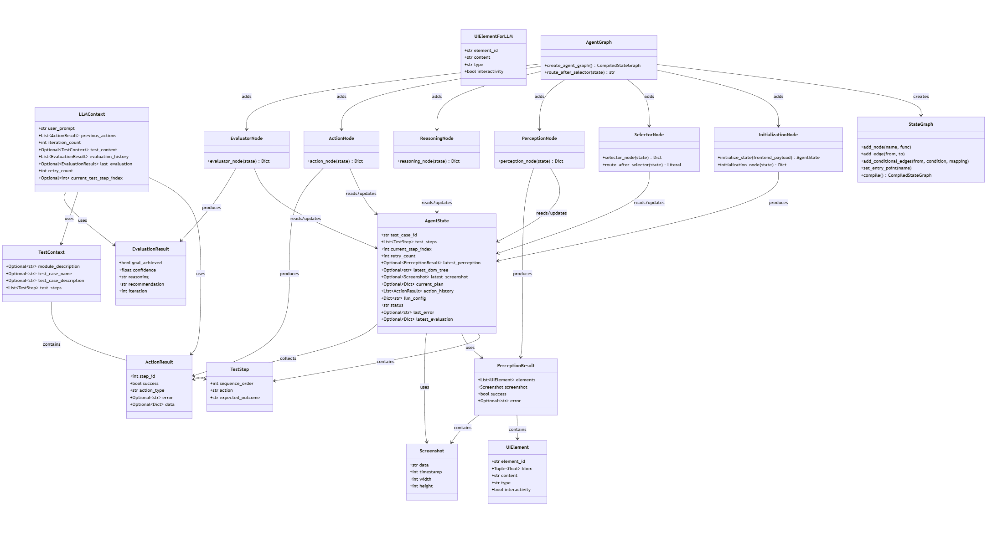
  - AI Agent Class Diagram

  - Sequence Diagram

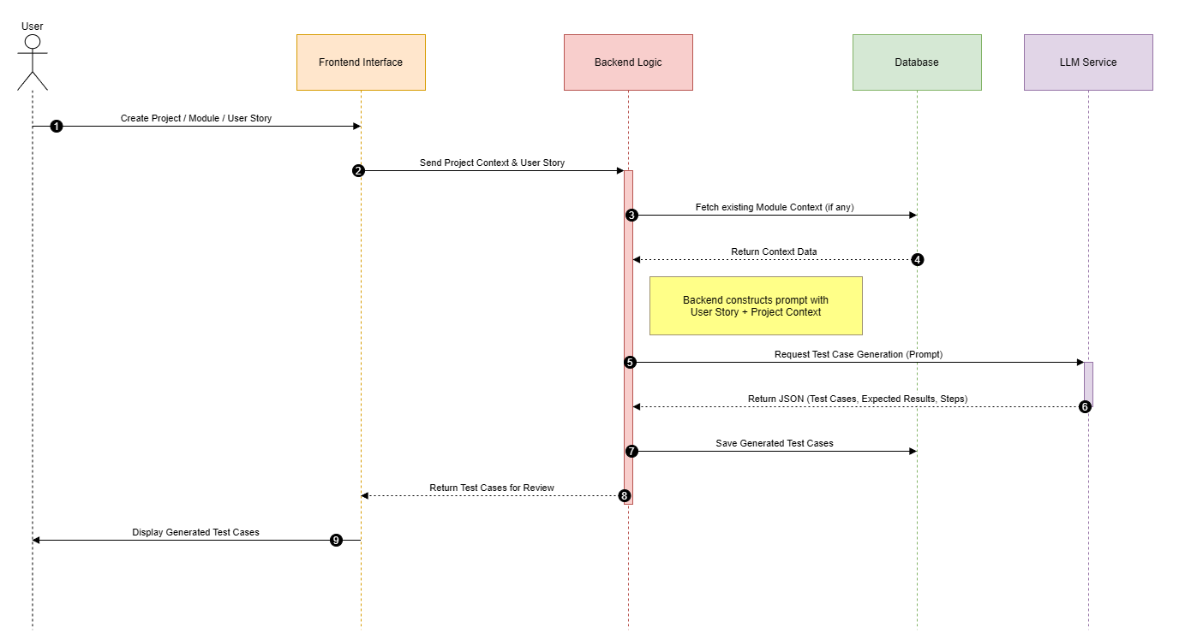
Figure 2 : Generate Test Cases Sequence

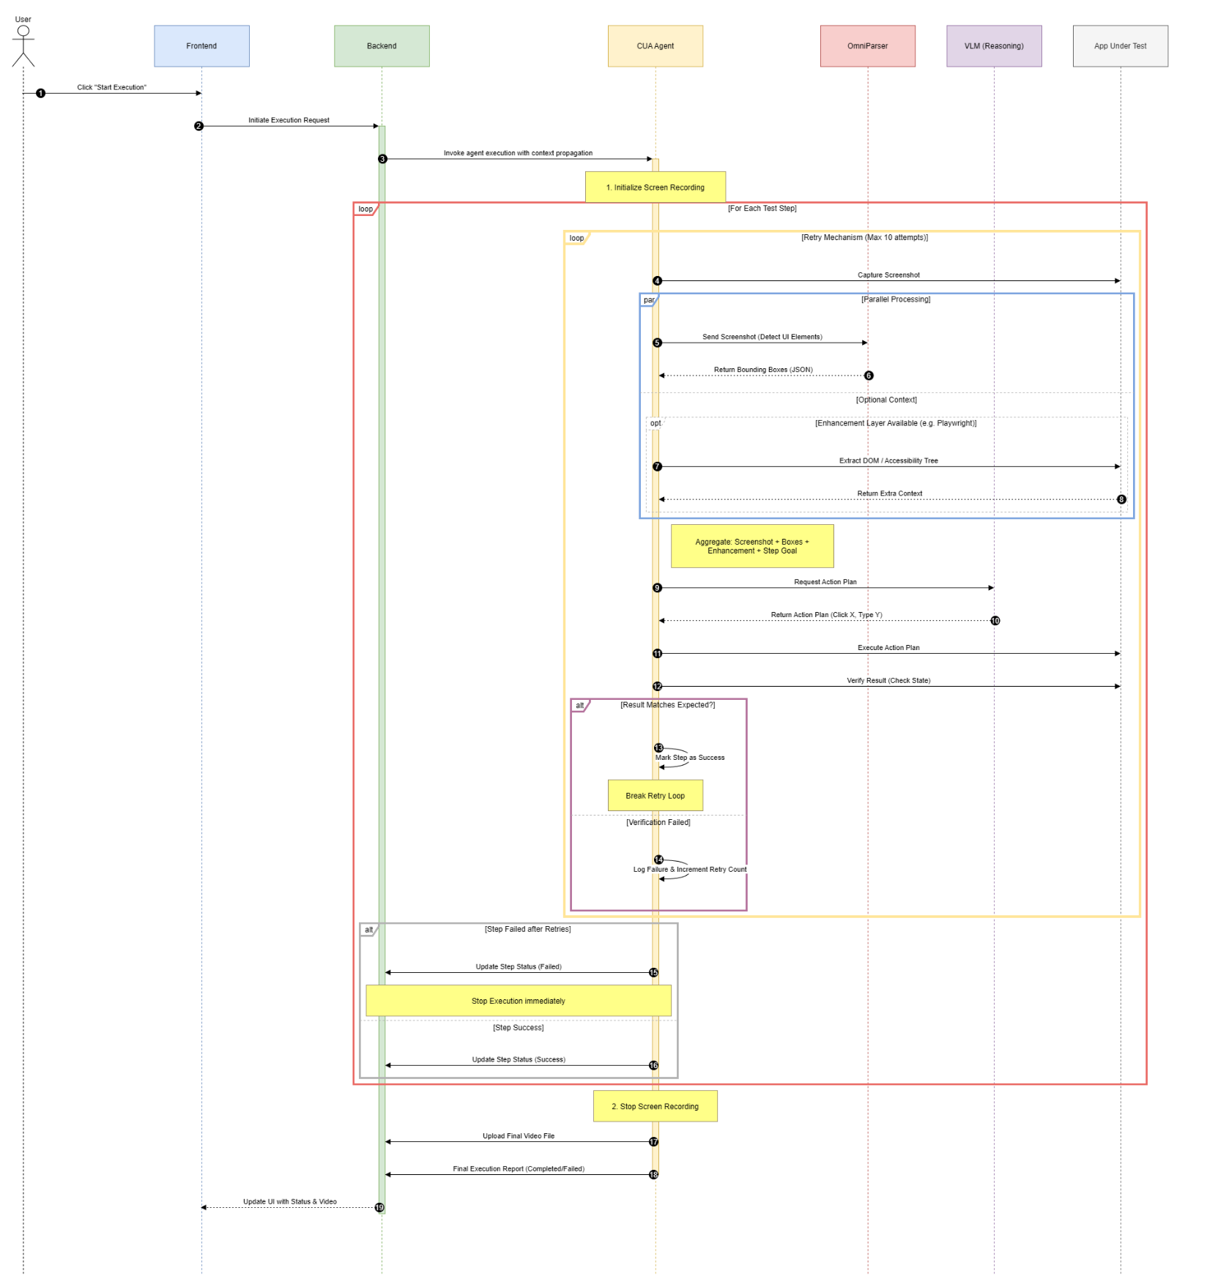
Figure 3 : Execute Test Sequence

  - Entity-Relation Diagram
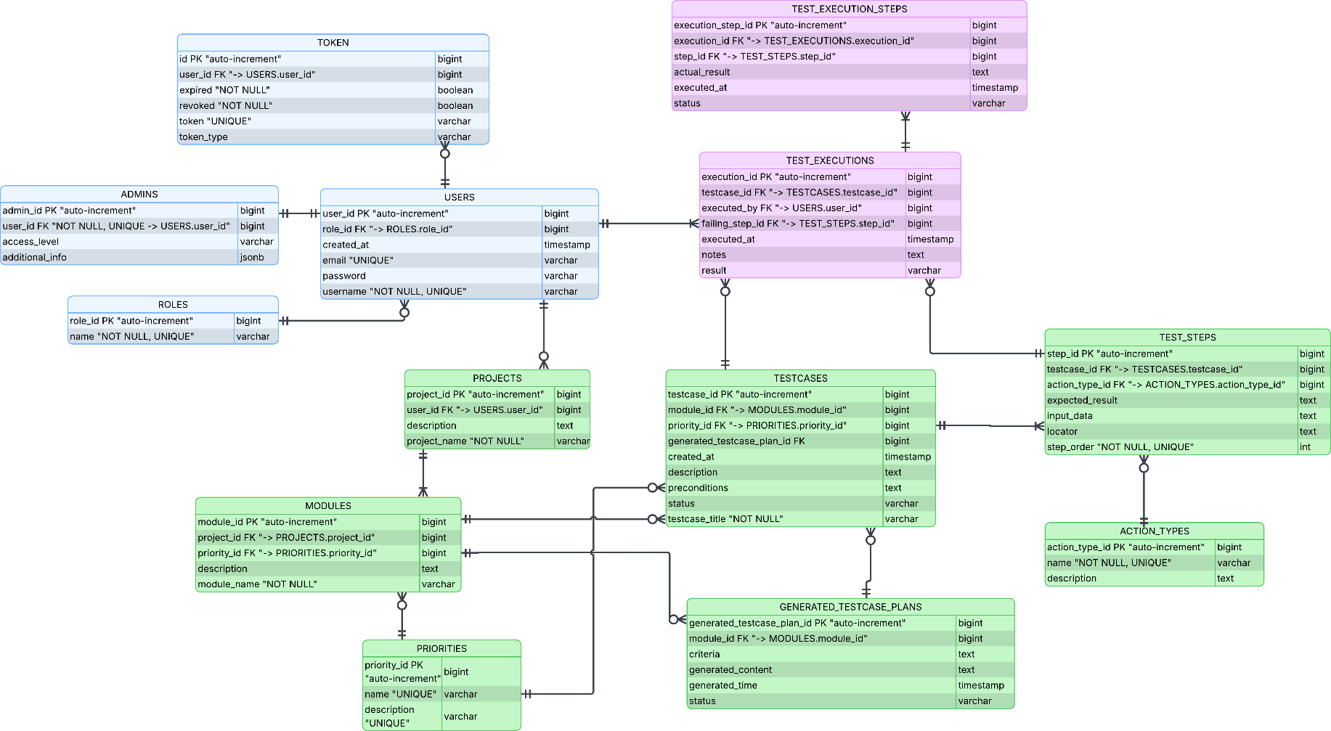

  - AI Integrations
We use multiple AI models for different parts of the project; here is a breakdown of the AI integration we have.
    - OmniParser V2
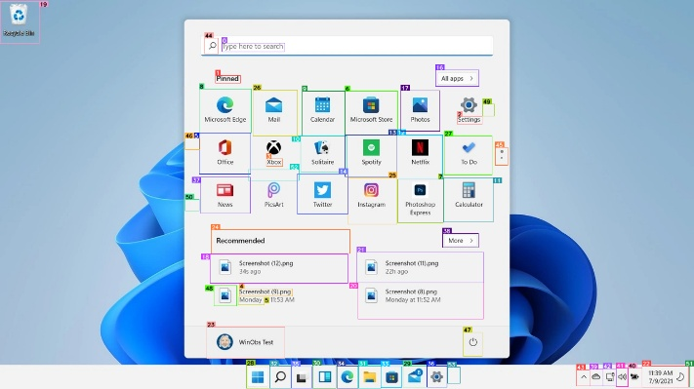
OmniParser V2 is the core engine of the parsing module. Its role is to transform a raw screenshot of the application under test into a structured, machine-readable representation of the user interface. Modern applications are visually rich and highly dynamic. When the system captures a screenshot, it initially contains only pixel data, with no inherent understanding of buttons, text fields, or other interface elements. OmniParser bridges this gap by analyzing the screenshot and extracting meaningful UI information.
Figure 4 Omniparser Results

The structured representation produced by OmniParser serves as a unified visual layer across all supported platforms:
- Web applications
- Desktop applications
- Android applications
By relying on visual understanding rather than platform-specific implementations, OmniParser enables consistent behavior across different environments.
When additional context is required, supplementary visual layers may be integrated, such as:
- DOM trees (for web applications)
- Element selectors or accessibility metadata
OmniParser is built using two complementary AI models:
- YOLO: Responsible for detecting and localizing UI components by identifying their positions and boundaries within the screenshot.
- Florence: Responsible for understanding the visual content, including recognizing text and associating semantic meaning with detected UI elements.
    - Vision Language Models
AI models designed to understand and reason about visual information and natural language together. Unlike traditional systems that process images and text separately, VLMs combine both modalities into a unified understanding.
In this system, VLMs enable the agent to interpret visual user interfaces and connect what is seen on the screen with language-based instructions, goals, and reasoning.
We use VLMs to do tasks like:
  - Identifying which UI element corresponds to a textual description (e.g., matching “Submit button” to a detected button on screen)
  - Assessing whether a test step was successfully executed based on visual feedback
  - Explaining why an action may have failed (e.g., an element is hidden, disabled, or blocked by another UI component)
  - Supporting decision-making for the next action to perform

- Work Plan
Task | Task Title | Task Description | Status
1 | Research Ideas | We performed research on latest CS papers to find inspiration for graduation project idea | Completed | Sept25
2 | Pick Niche and Scope | We picked the UI Testing Niche to limit the scope of our project | Completed | Oct25
3 | Design Prototype | We built simple Computer-Use Agent demo that performs actions using Natural Language | Completed | Oct25
4 | Database design | We designed a modular database schema with a hierarchy to break down tests effectively. | Completed | Nov25
5 | Agent Design | We designed basic agent to perform the perception-reasoning-action loop using LangGraph | Competed | Nov25
6 | Desktop App | We built a desktop application using Electron.js that consumes APIs from a Java Spring Boot backend with a PostgreSQL database. | Completed | Nov25
7 | Deploy AI Models | We deployed the server version of OmniParser on Theta machines to handle high-throughput parsing and heavy inference workloads. | Completed | Dec25
8 | Dockerize the database | We Dockerized the database to ensure consistent, isolated, and easily deployable environments. | Completed | Dec25
9 | Frontend Dashboards | We designed dashboard pages to track real progress on task execution | Completed | Jan26
10 | Agent Refactor | We refactored the agent for better maintainability, added detailed debugging features | Completed | Jan26
11 | Observability Enhancement | We added real time test monitoring, logging and video recording | Completed | Jan26
12 | Frontend features | We plan to add features that simplify test-case generation by creating blocks that define expected test behavior in the web app. | TBD | Feb26
13 | Exploratory Testing | Instead of generating weak negative test-cases, while executing positive one the agent will discover ways to break the successful test cases. | TBD | Feb26
14 | Agent Enhancement | We plan to integrate playwright MCP to our agent for better context understanding in web settings | TBD | Feb26
15 | Mobile Execution | We plan to integrate Appium to add mobile execution to our supported platforms | TBD | Mars26
16 | Database Refactor | Add new entities to support additional features and refactor existing endpoints. | TBD | Mars26
17 | Desktop Containers | Enable desktop container support to facilitate testing and execution of the desktop app. | TBD | Apr26
18 | Parallel Execution | Handle parallel test execution | TBD | Apr26
19 | Project Env Management | Allow users to securely store their testing credentials (test accounts – URLs etc.) | TBD | Apr26
20 | Role Based Access Control | Allow Hierarchical Access and dynamic permissions for each user type | TBD | May26
2 | Actions Auditing | Ensure database auditing for availability monitoring and execution debugging. | TBD | May26
22 | Create Commercial Website | Create a website to host the documentation, installation guides, and project information. | TBD | May26
24 | Documentation | Comprehensive user guide, API reference, developer setup instructions, contribution guidelines, and deployment documentation. | TBD | June26
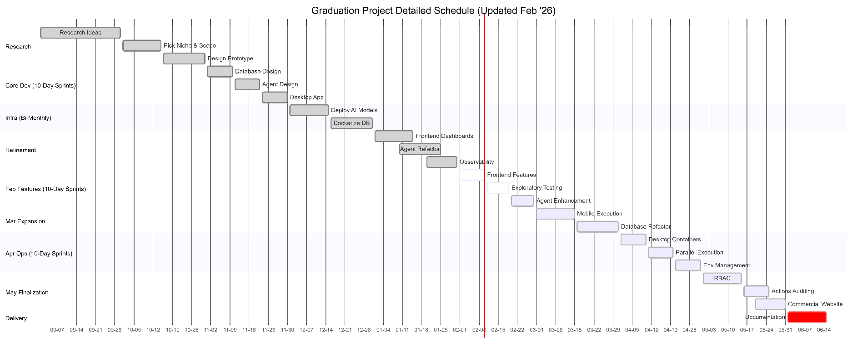
- References
[1] Y. Lu et al., "UXAgent: An LLM-agent-based usability testing framework for web design," in Proc. CHI Conf. Hum. Factors Comput. Syst. (CHI '25), 2025. doi: 10.1145/3706599.3719729.
[2] Y. Lu, J. Yang, Y. Shen, and A. Awadallah, "OmniParser for pure vision-based GUI agent," arXiv preprint arXiv:2408.00203, 2024. [Online]. Available: https://arxiv.org/abs/2408.00203
[3] C. Zhang et al., "AppAgent: Multimodal agents as smartphone users," arXiv preprint arXiv:2312.13771, 2023. [Online]. Available: https://arxiv.org/abs/2312.13771
[4] C. Wang, T. Liu, Y. Zhao, M. Yang, and H. Wang, "LLMDroid: Enhancing automated mobile app GUI testing coverage with large language model guidance," Proc. ACM Softw. Eng., vol. 2, no. FSE, pp. 1001–1022, Jun. 2025. doi: 10.1145/3715763.

